Partner update #13: COVID-19

Updated: 22 April 2020

Background
On 31 December 2019, the Government of China reported a cluster of cases of pneumonia of unknown cause in Wuhan, Hubei Province. A novel coronavirus was identified in January 2020. Since then, cases have been reported across China and in several other countries. On 30 January 2020, the WHO Director-General declared the COVID-19 outbreak a Public Health Emergency of International Concern (PHEIC).

NOTE: The situation is evolving rapidly. For the latest information, please check the WHO HQ and WHO WPRO Twitter accounts. Also refer to the COVID-19 dashboard for the Western Pacific Region.

Snapshot
- WHO has published an updated strategy for tackling the pandemic which will frame the next iteration of the Strategic Preparedness and Response Plan (SPRP).
- Yesterday, WHO hosted a virtual press briefing on COVID-19 in the Western Pacific Region. Read more or watch the briefing.
- The OneWorld #TogetherAtHome Global Special took place on Saturday, 18 April 2020. It is a cross-platform gathering of artists and musicians to celebrate and support healthcare workers and others on the frontlines, as well as WHO, and to raise funds for the global response to the COVID-19 pandemic.
Key issues
- US funding
On 15 April, WHO Director-General Dr Tedros said: “The United States of America has been a longstanding and generous friend to WHO, and we hope it will continue to be so. We regret the decision of the President of the United States to order a halt in funding to WHO. With support from the people and government of the United States, WHO works to improve the health of many of the world’s poorest and most vulnerable people. WHO is reviewing the impact on our work of any withdrawal of U.S. funding and will work with our partners to fill any financial gaps we face and to ensure our work continues uninterrupted.” As the UN SG said on 14 April, WHO must be supported, as it is absolutely critical to the world’s efforts to win the war against COVID-19 and now is not the time to reduce the resources for the operations of WHO or any other humanitarian organization in the fight against the virus.
- Guidance on adjusting public health and social measures
This week WHO released Considerations in adjusting public health and social measures in the context of COVID-19. This document provides guiding principles for adapting measures. This will be followed by indicators for when measures can be adapted and by practical advice on how to adapt measures in key settings such as schools and workplaces. Partners are encouraged to share and help national authorities adopt this guidance and highlight that there should be gradual alleviation, close monitoring and constant calibration of measures. As measures are loosened, surveillance should be tightened. Different surveillance approaches (identification, confirmation, isolation, and contact identification and quarantine, event-based surveillance, sentinel ILI/SARI surveillance etc.) should be applied.
- Erroneous reports on WHO ‘approval’ or re-opening wet markets in Wuhan
There are incorrect reports on WHO’s view on the re-opening of wet markets in China. WHO advises that all sectors affected by COVID-19, including food markets in China and around the world, must ensure strong regulatory systems, high standards of cleanliness, hygiene and safety once they are in a position to gradually resume normal activities. WHO also advises governments to enforce bans on the sale of wildlife and enforce safety and hygiene regulations to ensure that food sold in markets is safe. WHO provided guidance to countries on safe and healthy markets in the context of COVID-19, and on food safety and live markets.
- Safe Ramadan practices
Guidance on safe Ramadan practices in the context of COVID-19 offers public health guidance for social and religious practices and gatherings during the holy month of Ramadan (23 April-23 May; dates may slightly change). The guidance also offers advice to strengthen mental and physical well-being to live in full the spirit of Ramadan as the COVID-19 pandemic continues. Partners are encouraged to disseminate to national health authorities with the aim of facilitating planning of gatherings happening during Ramadan, or immediately preceding and following it and encourage early involvement of religious leaders so that they can be engaged in communicating decisions affecting events.
Resources

Web pages
WHO global webpage on COVID-19
WHO regional webpage on COVID-19
Global situation dashboard
R&D blueprint
Global research on COVID-19

Situation reports
Latest SitReps

Donors and partners
COVID-19 Partners Platform
COVID-19 Solidarity Response Fund
Donor alert (4 February)
Funding
Global Strategic Preparedness and Response Plan (February to April 2020)

Twitter accounts
@WHO
@WHOWPRO
Regional Director @takeshi_kasai
NOTE: Twitter is usually the first place where official case counts are reported

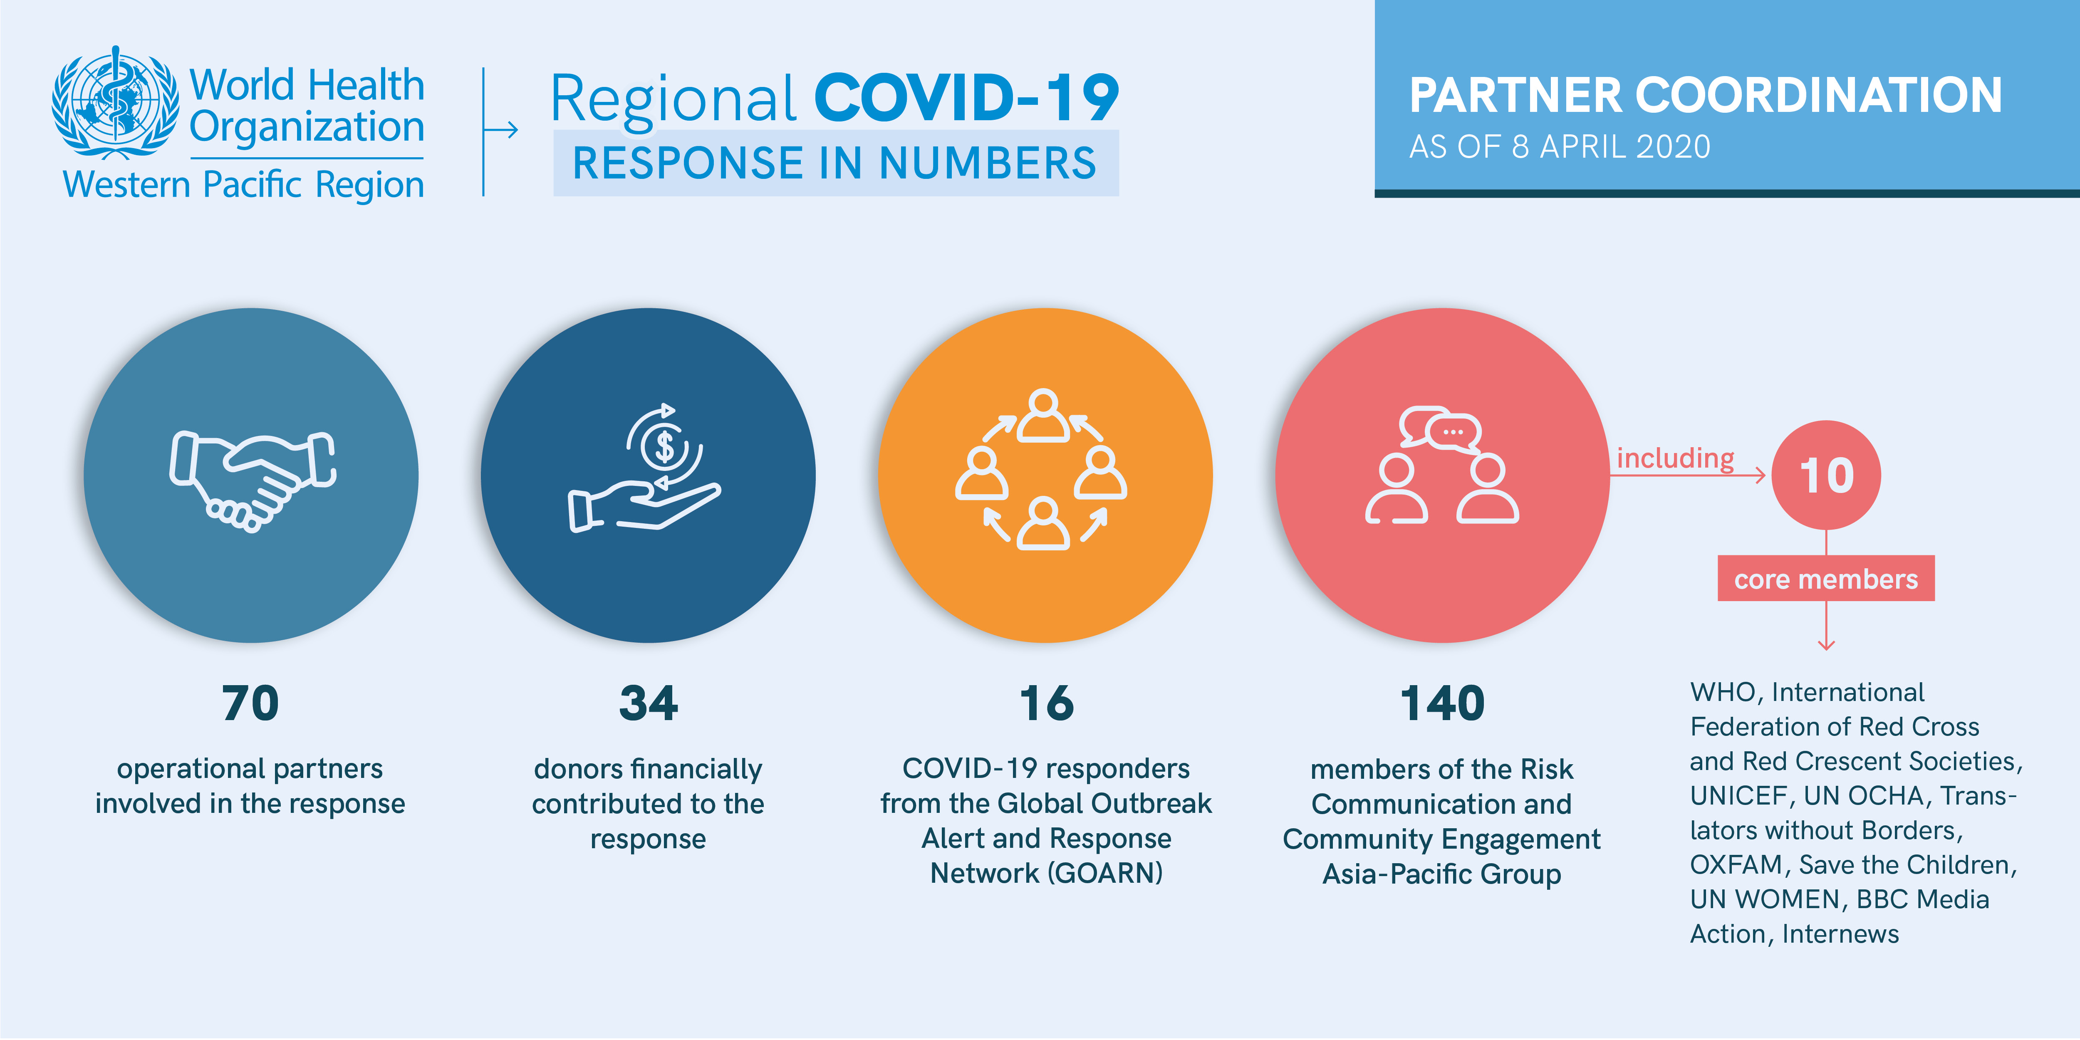

Latest news
*NEW* Press conference on COVID-19 outbreak in the Western Pacific Region (21 April)
*NEW* WHO DG's opening remarks at the media briefing on COVID-19 (17 April)
*NEW* More than 117 million children at risk of missing out on measles vaccines, as COVID-19 surges (14 April)
*NEW* Staying safe during season of religious and cultural events, amid the COVID-19 outbreak (14 April)
Media resources (WHO HQ press briefing audio recordings and transcripts)

Technical guidance
Interim guidance on the following topics is available from this web page:

- Country-level coordination, planning, and monitoring
- Case management
- Risk communication and community engagement
- Points of entry / mass gatherings
- Surveillance, rapid response teams, and case investigation
- Infection Prevention and Control / WASH
- Operational support and logistics
- Naming the coronavirus disease (COVID-19)
- National laboratories
- Early investigations
- Reduction of transmission from animals to humans
- Critical preparedness, readiness and response actions for COVID-19

Travel advice
International travel and health

Advice for the public
Q&A on coronaviruses
Healthy parenting
Preparing your workplace for COVID-19
*NEW* WHO on Messenger, WhatsApp and Viber
How to protect yourself
Advice on the use of masks
Myth busters
‬‬‬‬‬‬‬‬‬‬

For more information and the latest updates
Follow @WHOWPRO (updated case numbers for the Region posted daily) and @WHO on Twitter, and/or go to the WPRO website.

