TORs Governance Structures
Disaster Risk Financing System - DRF
Pakistan
- Background:
The Start Network is in a process of forming Disaster Risk Financing DRF system in Pakistan that allows civil society actors in country to pro-actively manage disaster risks like heatwave droughts and floods. This will be done through the scientific modelling of hazards, collaborative development of contingency plans and the establishment of pre-positioned financing to enable earlier, more predictable and better coordinated assistance to communities affected by disasters. The DRF system will be the future financial infrastructure of the Start Network. Through the system Start Network and its members will be able to deploy funds in timely, predictable and efficient ways to frontline NGOs. The long-term goal is to incorporate existing Start Network funding mechanisms as well as new instruments, to provide a continuum of funding that will enable all members to better protect communities at risk.
WHH, Pakistan has been selected as host organization to provide the administrative, logistical and technical support for the development of national DRF systems in Pakistan through formation of Start Network Hub. The Hub will play a pivotal role by acting as a central coordination point for all Start Network activities in country. For the system to function initially and evolve itself subsequently, following governance structure and ToRs are suggested.
Figure No 1
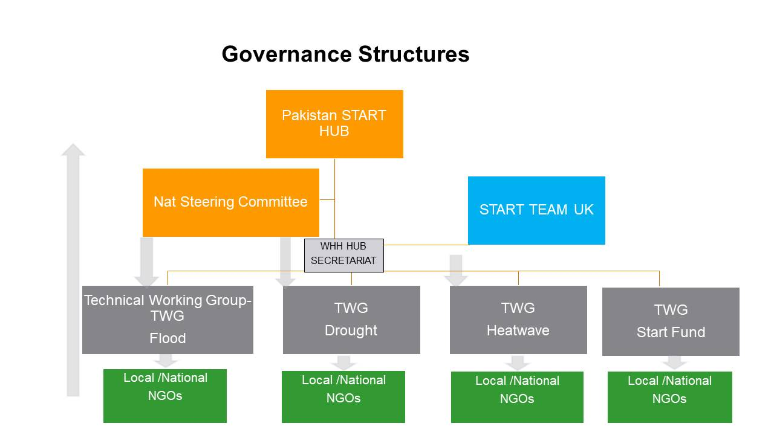
- Governance Structures

  - National Steering Committee- NSC
This is the highest governing body in the structure of DRF to provide strategic directions to DRF system in Pakistan. This committee will ensure that the DRF fits into the wider humanitarian landscape in Pakistan and complements other early action and localization efforts in country. This committee would provide strategic direction to DRF system by operational management, building national expertise and strengthening partnerships in disaster risk financing. This committee was established in 2019 by existing members of Start Network Hub know as Hub Realization Team, details mentioned subsequently.
  - Purpose:
The purpose of the committee would be:
- Strategic advice and overall supervision of the DRF system in Pakistan
- Building national expertise and strengthening of DRF partnerships
- Decision on fund allocation
- Decision on launch of alerts and approval of response activities
- Developing linkages with organizations/groups, other early actions and localisation efforts in Pakistan

  - Technical Working Groups (Floods, Heatwave and Drought)
A total of four groups are required to be established one group each for Flood, Drought and Heatwave while a fourth for Start Fund Response. The details of Start Response will be added in the document by the Start Fund Focal Person in Pakistan. Considering the importance of TWGs in DRF system and their technical, operational and coordination functions (given in detail in protocol document) there is an urgent need to form these groups on priority.

  - Purpose
- Technically and operationally develop, establish and manage the DRF system in Pakistan
- Ensuring preparedness mechanisms and contingency plans are in place
- Collaborating and coordinating anticipatory response activities with and between stakeholders
- Quality assurance of all activities
- Reporting to NSC on all important matters requiring its input

  - Composition 9-11 Members
Ideally, each group will have 9-11 members selected from responding organizations who have appropriate experience and presence on the ground and can work together to best prepare for disasters such as heatwave, flooding and drought. These members will be from a variety of stakeholders involved in anticipatory response and risk financing to include government (PDMA), local NGOs, private organizations and hazard specific experts. The membership of this committee will be open to Start Network members and non-members alike. The members of TWGs will be nominated according to criteria of selection by NSC. However, at this inception stage efforts will be to have maximum and equal representation from Intl and local NGOs with other technical members in TWGs.
- As an initial (ad hoc) arrangement till June 2021 following appointments are made. These nominations have been done to develop linkages between TWGs operationalization and steering committee:
  - Liaqat Ali Indus Consortium appointed as Chair of Flood TWG. The representation of non-Start members is essential for maintaining diversity within TWGs.
  - Jennifer Ankrom CD ACF appointed as Chair Heatwave TWG
  - Syed Sulaiman Concern Worldwide appointed as Chair Drought TWG
(Fresh nominations will be sought from all organizations by the newly appointed Chairs of TWGs on proirity)
- After June 2021 the Chair and Co-Chair will be appointed through elections within the appointed members of TWGs
- An organization can only be part of one TWG at one time and the nominated organizations will provide names of two representatives (one principal and other as reserve) to be members of TWG
- Both TWG members will take part in training and capacity building activities. The training will be mandatory for each member of TWG
- The TWGs shall follow Start Network Mechanism for approval of submitted proposals

  - Criteria:
The criteria for inclusion in these technical hazard specific groups will be as follows. The nomination of members will be sought by chair/ co-chair whenever required, (nomination form is attached) and the members will be nominated in consultation with NSC:
- Presence on ground and participation in anticipatory response for either of the above noted hazards in anticipatory response.
- An experience of humanitarian action in Pakistan in the past
- Knowledge of climate science and familiarity and hazard knowledge of droughts and floods
- Relationships with donors or potential donor organizations, who could earmark funds to the DRF, once built
- Experience of financial tools/instruments used for disaster risk financing DRF that can be used to leverage contingency funding

  - Functions:
The technical groups will perform critical hazard forewarning, technical and operational functions. The groups are expected to meet whenever deemed necessary to perform following functions: Details of functions and time lines are attached as protocol document.
- Forewarn
  - To understand and operate the scientific models for heatwave, floods and drought anticipation developed by DRF Technical Team of START for triggering anticipatory response
  - Arranging for training and capacity building of members on scientific models for heatwave, floods and drought with the assistance of Start Network
  - Formulate guidelines to standardize and improve need assessment, preparedness planning and proposal development processes/ protocols for assisting partners
  - Be prepared to issue timely alerts to all partners/ organizations on ground
- Technical
  - To monitor the progress of preparedness activities and technically review the proposals for various hazards that will be activated when a trigger is met
  - The TWGs shall follow Start Network Mechanism for approval of submitted proposals

- Operational and Coordination
- Receive and disseminate alerts: Timely receiving information from (DRF Hub/ steering Committee) and disseminating it to (implanting partners) when hazard trigger is met
- Coordination with all relevant organization , DRF Hub and Steering Committee before, during after the response actions
- To oversee the progress of ongoing response activities and report to DRF Hub and Steering Committee
- Ensure quality and accountability in all activities especially response by the member organizations
- Any other technical or operational task assigned by the National Steering Committee.

  - Reporting: All the groups will report to National Steering Committee.

*************************

